* Cura5.0 Download url: <https://github.com/Ultimaker/Cura/releases>
* Download the configuration file ：<https://github.com/NARUTOfzr/Cura5.0-Neptune-TEST>

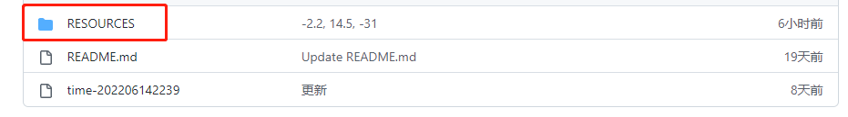

Note：Only one method can be used.

* **Neptune series machine configuration methods：（Simple）**

1. Open ”resources” folder, then copy files below.

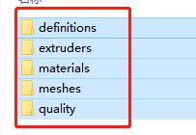

1. Fire up Cura5.0, head to help→Show Configuration Folder

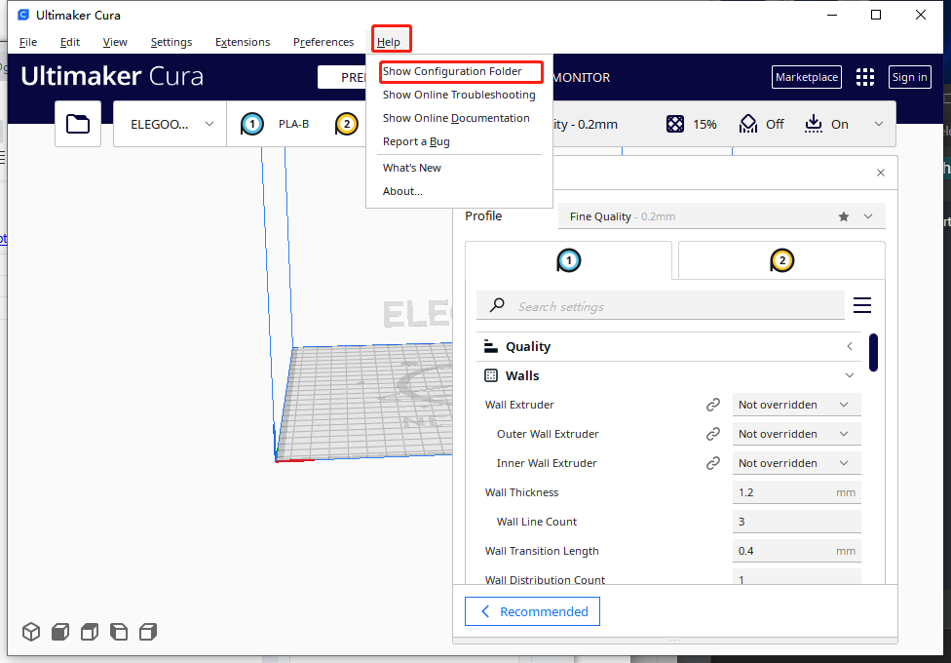

1. Click the blank area and paste the files. Merge folders then open cura.

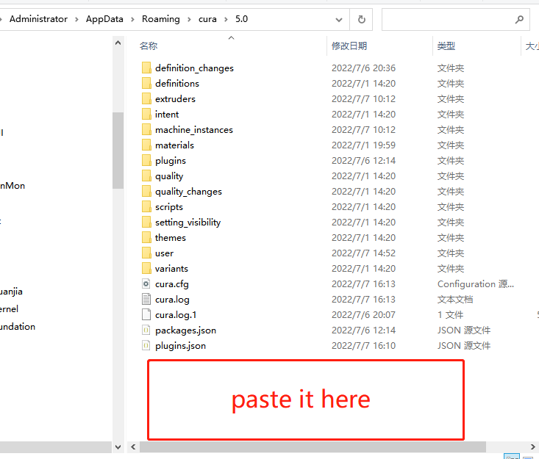

**Neptune model configuration method 2: (more troublesome)**

1.Install cura5.0 and remember the installation directory.

2.Find this folder in the installation directory, click on the blank space, then paste the copied "resources" folder into the current directory, and merge the "resources" folder.

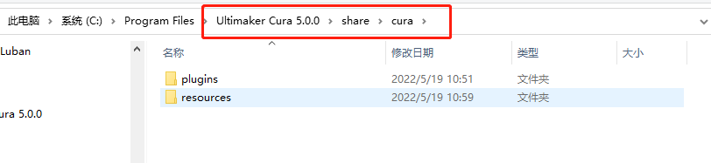

3.Restart "Ultimaker-Cura-5.0.0" to see related ELEGOO-NEPTUNE series models.

